Assignment 6 NetProg CWM
Yuzhe Jin
Brasenose College
Repository Link:
https://github.com/MrJimbo2002/CWM-ProgNets/tree/main/assignment

What I have done is to make a firewall operating to only allowing white list packet transmitting. To make it more realistic applicable, I added a register based counter to set up a maximum quota in case the white list packet becomes “unsafe” for the sudden increase of transmission rate.

Fig 1 shows the white list packets under the quota as below.

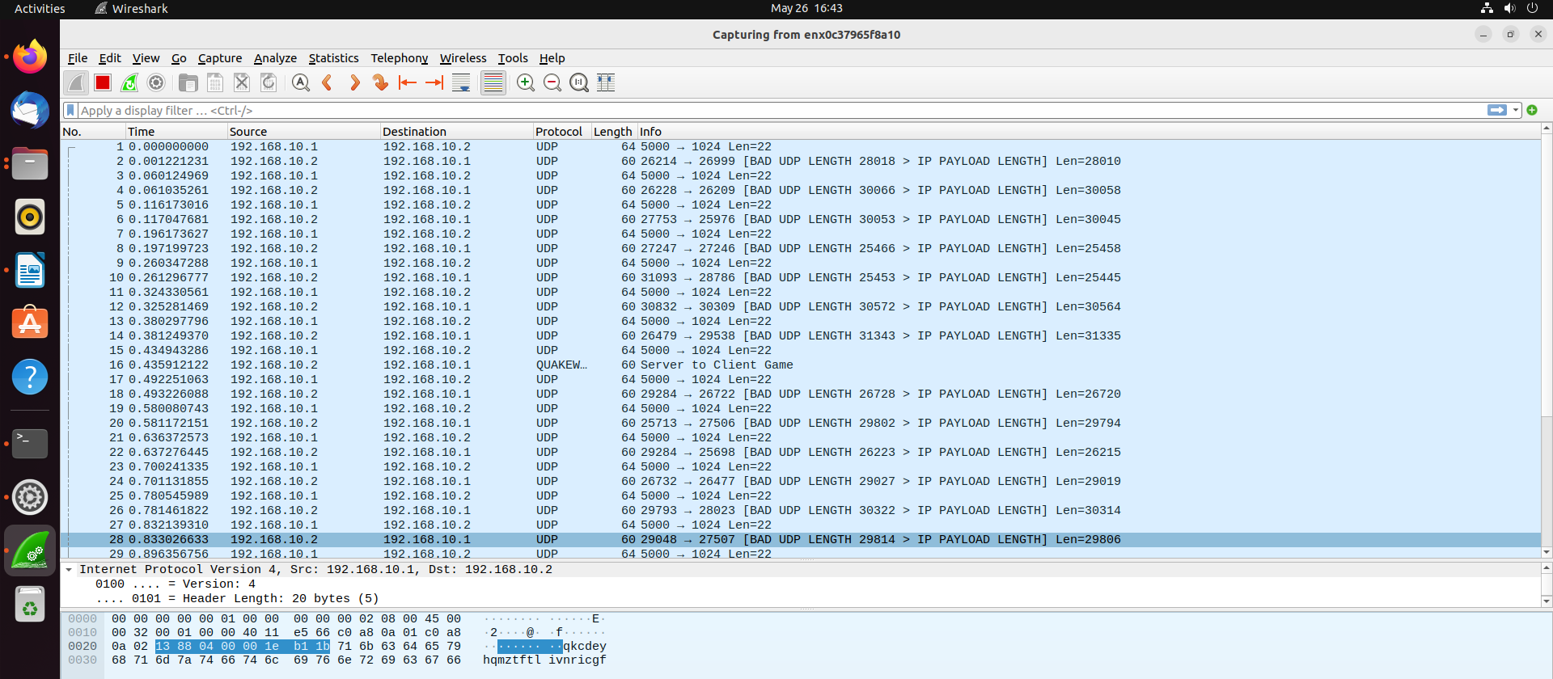
Fig 1

Fig 2 shows the white list packets exceeding the limiting quota.
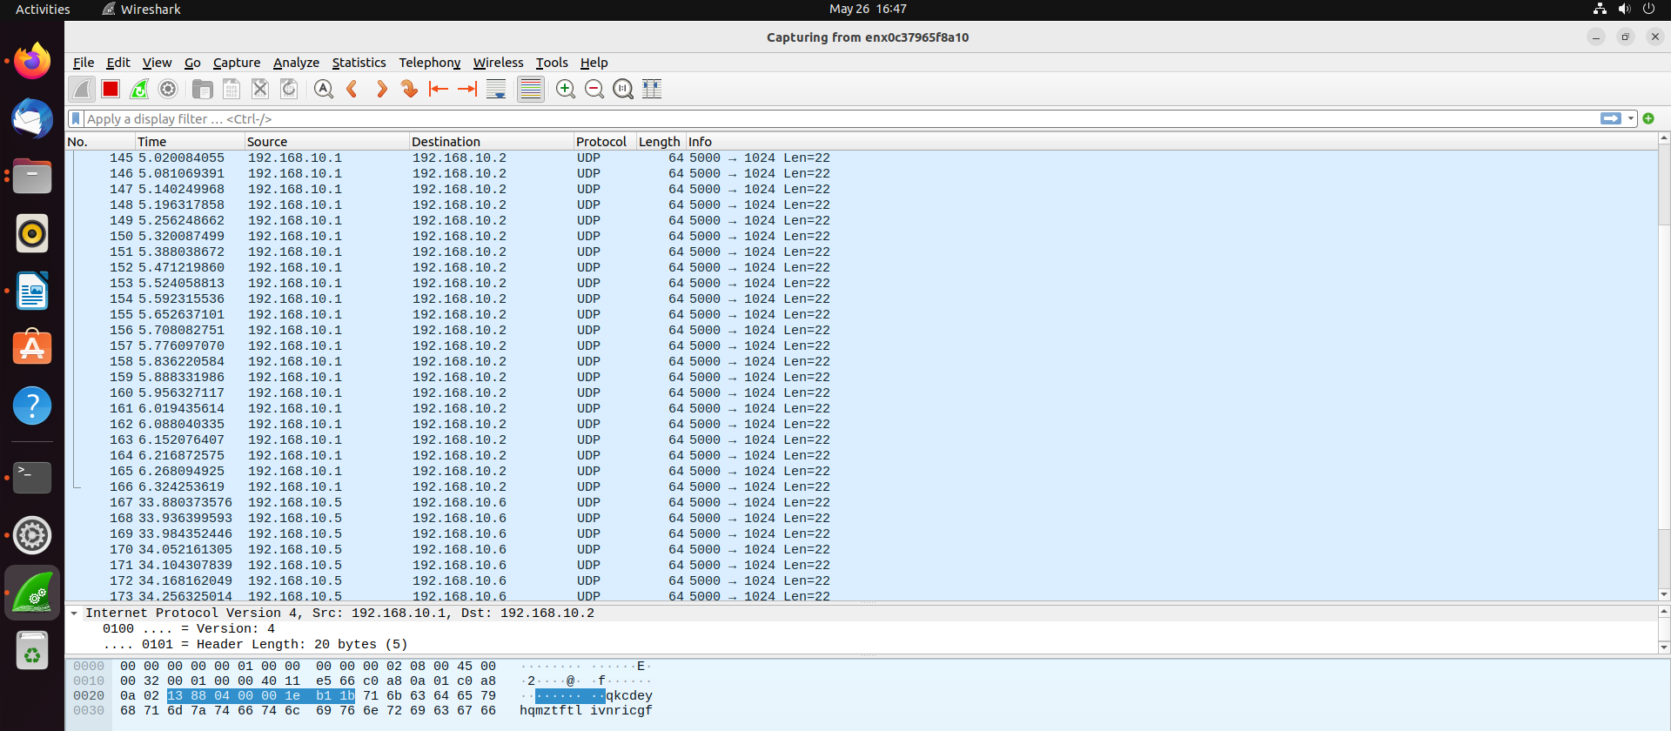
Fig 2
Fig 3 illustrates all packets being blocked outside the firewall for the non-white list packet tracking.

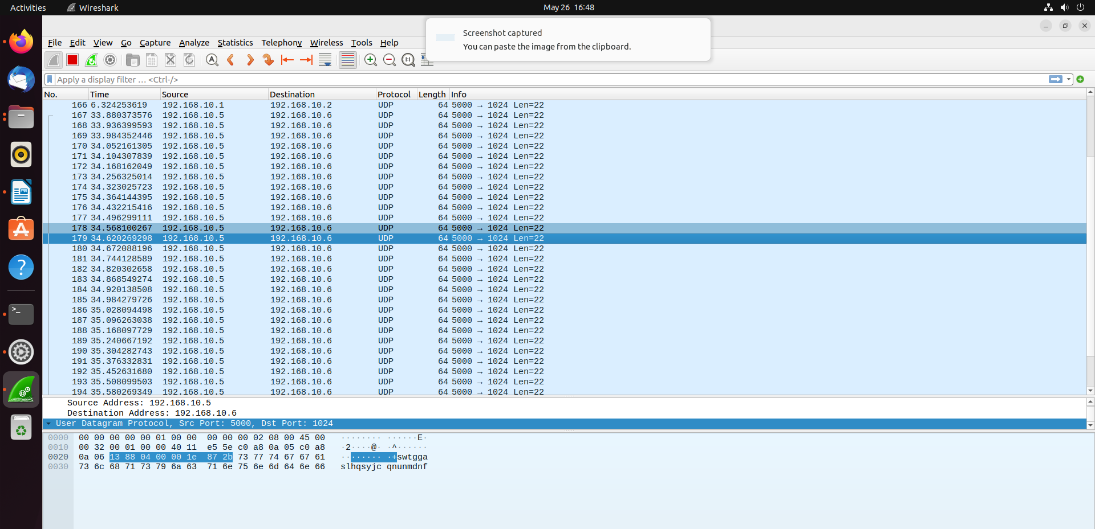
Fig 3

The Pi interface corresponds to the Switch-Limit-Interface to add the following white list packet information.

